**Note: Requires DOTween – http://dotween.demigiant.com/**

This is a WSIWYG UI for Unity, animated by eases with the intent to make an easy system by 1) creating a UI by hierarchy and with Unity’s default tools, and 2) by then making linkages between menus to animate

Using Unit’s new UI system with a Canvas, the expected hierarchy would be:

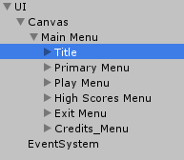

Note that menus are not nested, each menu is on the same level of the hierarchy regardless of how many levels deep it is in-game. This is to promote WYSIWYG and management when changes are to be made.

Main menu will follow the form of the follow hierarchy:

Menu Object (Primary Menu) – **UI_Menu**: Dictating the size and shape, and look of the menu  
Button Group Object (Primary Buttons) – **UI_ButtonManager**: Manages child buttons (colors, etc.)  
Button Objects (Play_Button, Scores_Button…) – **UI_Button**: Each buttons’ individual behaviors

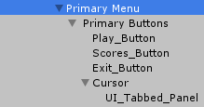

Secondary, tertiary or other menus will be on the same place in the object hierarchy but use **UI_SubMenu** instead of **UI_Menu**. There can be only one main menu (**UI_Menu**) but multiple sub menus (**UI_SubMenu**).

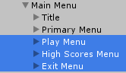

Linkages between, references to, and animations are all handled by the scripts corresponding to the menus and are set in a WYSISYG fashion, with references easily drag-and-droppable:

Examples:

|  |  |
| --- | --- |
| **Primary Menu (UI_Menu)** | **Play Menu (UI_SubMenu)** |
|  |  |

**An example of an what this can achieve is available on YouTube, but please note this is an earlier prototype and does not show use of sub menus or buttons:**

[**https://www.youtube.com/watch?v=KVH6A6LVRTc**](https://www.youtube.com/watch?v=KVH6A6LVRTc)